
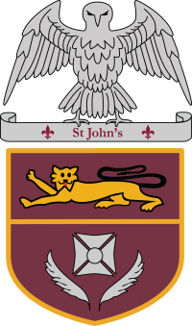
St John’s Church of England School, Stanmore
‘I can do everything through Christ, who gives me strength’
Philippians 4:13

Application for Free School Meals and the Pupil Premium
St John’s is able to perform a quick and easy eligibility check on your behalf. We only need your date of birth and National Insurance number.

If you would like the School Business Manager to confidentially check on your behalf, please complete the slip below and return it to the school office in an envelope marked Free School Meals.

------------------------------------------------------------------------------------------------------------------------------------------------------------------------------------------

FREE SCHOOL MEALS ELIGIBILITY CHECK

Name of child: ………………………………………………… Child’s date of birth …………………..…....………..….... Class ………………….

Parent’s Full Name …………………………………………………………… Parent’s date of birth ………………………………

Parent’s National Insurance Number ………………………………………………….

Parent’s Signature…………………………………………………………………….. Date………………………………………..

